Design Specification: CyberCertify
Project: CyberCertify – Gamified Cybersecurity Training Platform
Module: KV6014 – Group Computing Project

Introduction
The purpose of this document is to present the design specification for CyberCertify. This specification includes both low-fidelity and high-fidelity designs that demonstrate the structure of the platform. It outlines elements such as the registration flow, sign in page, quiz interaction flow, learner dashboard, admin dashboard, business verification, certificate generation and overview, trust badge, reports and settings. The document also includes a style and application guide which defines the colour palette, typography, and rules for components to ensure consistency throughout the document. Each section explains the design choices made, showing how CyberCertify’s approach differs from competitors by focusing on simplicity, motivation and user engagement.
Colour Palette & Application guide.
Application guide:
- The main page background is white (#FFFFFF) for a simple appearance.
- The design utilises soft neutral colours with blue accents.
- Shadows and subtle gradients are used to create depth and bring forward important aspects of the page.
Cards and Containers:
- Card Background: White (#FFFFFF), with a stroke/border of Off White(#DEDEDE) to make it stand out.
- Card Shadow: Each card has a soft drop shadow to lift it off the page.
- Inner Containers: Containers within cards use the same #DEDEDE stroke/border but without a shadow to showcase that they are within a group.
- For important cards or sections, use a gradient background or static colour background using a range of colours like the accent colour (#6093E6)
  - #F6F9FF to #EDF2FF to create contrast and highlight key areas.
Buttons:
- Primary Buttons:
  - Background colour: #284066
  - On hover: use a darker shade of the same colour for feedback.
  - Text colour: white for contrast.
- Common Buttons (e.g., header and footer actions)
  - Background colour: #1C3359
  - On hover: use a darker shade of the same colour for interaction feedback.
  - Text colour: white for contrast/ readability
Text and Typography:
- Font Family: “Inter”
  - Inter is modern, and designed for user interfaces, it is familiar and widely used which gives the application a sense of comfort.
  - Regular weight for body text and bold for headings, course titles, and section headers.
- Text colour depends on background:
  - On light backgrounds, use dark text for readability.
  - On dark backgrounds, use light text for contrast.
- Information text (e.g., stats or XP next to progress bars) should use #6093E6, the same as the accent colour to visually connect them.
Accent & Highlights:
- Progress bars use the accent colour #6093E6.

Icons
- Icons are sourced from:
  - Material Design Icons.
  - Icons8.
- Used within the application to create familiarity with the users.

Summary of Key Colours

Element | Colour | Description
Background | White | #FFFFFF
Border/ Container | Light Grey | #DEDEDE
Accent | Soft Blue | #6093E6
Primary Button / Main UI | Deep Blue | #284066
Common Buttons | Navy Blue | #1C3359
Secondary Dark | Slate Blue | #2E3A4D
Extra Deep Contrast | Midnight Blue | #032152
Gradient Accent | Light Gradient End | #EDF2FF
Gradient Accent | Light Gradient Start | #F6F9FF

Visuals
Contains designs and justifications.
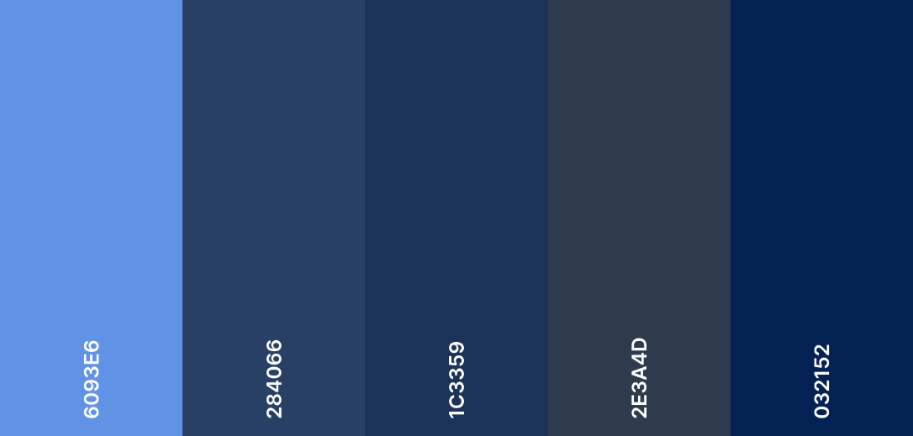
Figure 1 Colour Palette (Coolors.co)

Figure 1 Colour Palette (Coolors.co):
The palette utilises a monochromatic feel of cool tones from soft blues (#6093E6) to midnight blues (#032152). This creates a hierarchy within the application; lighter tones highlight progression and statistics, while darker tones highlight navigation and guide the users. Will be applied for the hi-fidelity designs.

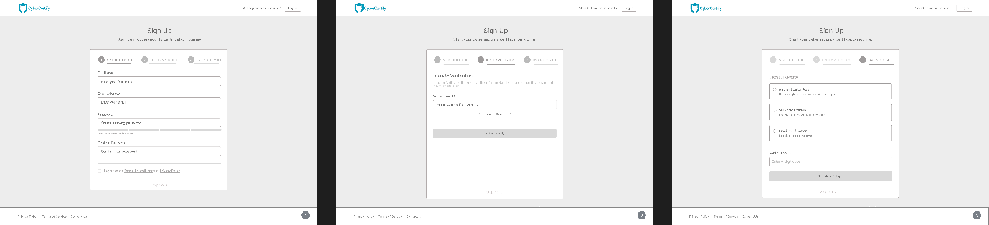
Figure 2 Registration flow
Figure 2 Registration flow:
Justification
The registration flow was designed as a three-step process to make signing up easier for users. Splitting the process into three steps helps users stay focused and reduces mistakes. This approach compared to competitors like KnowBe4 and Cybrary is more user friendly because instead of a long single-page form that users need to fill in, they instead get guided through registration stages which overall just improves user experience.
Adding identity verification and two-factor authentication (2FA) during the sign up makes CyberCertify stand out. While most of our competitors only use basic login methods, our flow introduces secure habits very early on to reflect the platforms cyber security focus.
These low-fidelity wireframes focus on layout and user flow rather than visuals. Each step is designed around a specific thought-out action, which guides users through the registration process, and overall supports the goal of CyberCertify which is making cybersecurity learning secure and easy for all individuals.
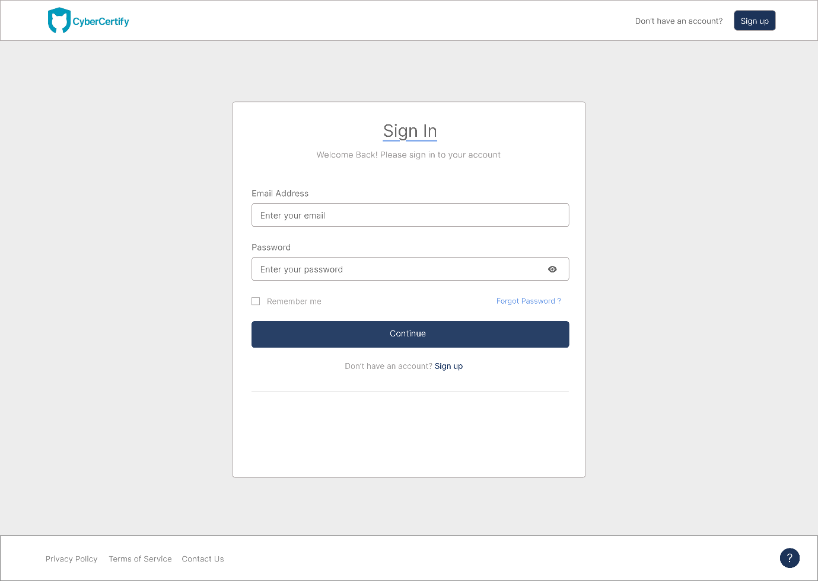
Figure 3 Log in design
Figure 3 Log in:
Justification
The sign-in page is simple and familiar, allowing users to log in quickly. The centred form uses clear spacing and large input boxes to make it easy to read and fill out. A single main “Continue” button guides the user to completing the form. The dark blue is taken from the colour palette (figure 1), and it stands out clearly against the light background. Supporting links like “Forgot Password?” and “Sign up” are placed just below the form for further guidance. Consistency with the header and footer brings familiarity to the users throughout the whole application. This sign-in layout follows the familiar and trusted layout used across most platforms, including KnowBe4 and Infosec. The overall goal for this layout was to ensure it's as familiar and easy to use for all users.
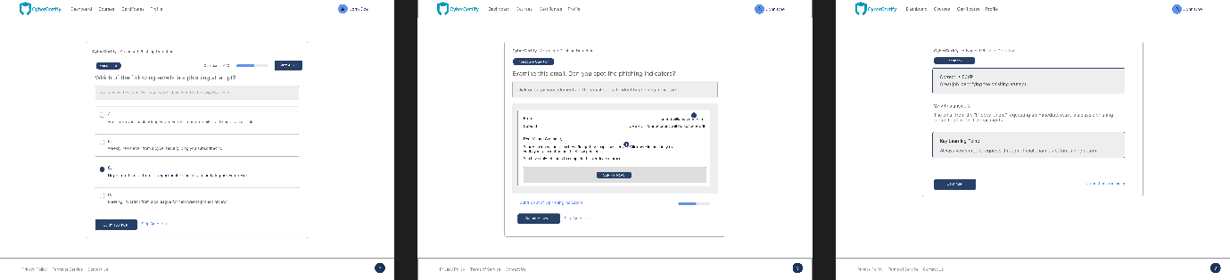
Figure 4 Quiz interaction flow
Figure 4 Quiz interaction flow:
Justification
The quiz flow is designed to make learning interactive, engaging, and easy. It includes three main screens/formats, a multiple-choice quiz, a scenario-based question and a feedback screen. Using different styles of quizzing ensures learners remain interested and overall improves both knowledge and decision-making skills.
Each layout uses a clear and recurring structure to ensure familiarity, with good spacing, large clickable options, and visible progression indicators. This ensures that the interface is easy to use for all users. The feedback screen helps guide the user further by explaining why an option is correct or incorrect and showcasing their progression through the course by using XP points. Showing key learning points reinforces understanding and ensures active learning.
Other platforms such as KnowBe4 and Infosec mainly use static quizzes or videos, which can be repetitive. CyberCertify’s design adds interactive scenario-based questions and detailed feedback after each section to ensure that the experience is more engaging and practical. This approach turns cybersecurity training from a repetitive and passive experience into a game-like, active and progressive one.
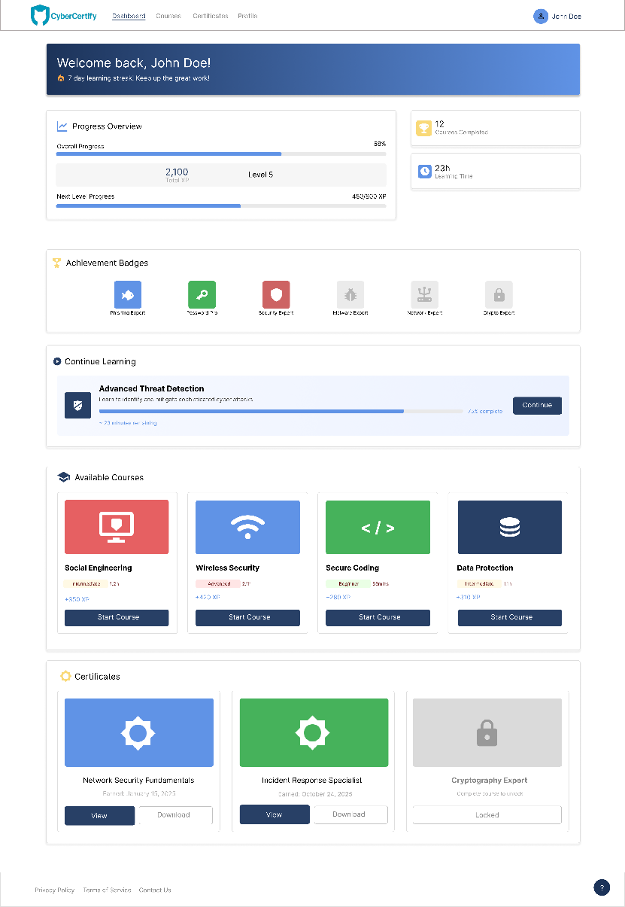
Figure 5 Learner Dashboard
Figure 5 Learner Dashboard Design:
Justification
The learner dashboard is designed to give learners (users) a clear overview of their overall progress and achievements. It uses a clean and consistent card-based layout to make information easy to read. The first thing the user is greeted with is a welcome banner and progress section, which are located at the top of the screen. These cards contain and show total XP, level, and completion rate, giving learners instant feedback.
Achievement badges are displayed on their own container to grant motivation to learners and reward progress, while the Continue Learning section lets users easily return to their last course quickly with no navigation hurdles. The Available Courses section uses coloured cards to showcase difficulty levels and XP rewards, allowing users to decide what their next course will be. Finally, the certificates section provides a simple way to view and download earned certificates from completed courses, overall allowing users to view their accomplishments.
The design creates a balance of efficiency and motivation which ensures the dashboard is clean and easy to use. Competitors such as KnowBe4 and Infosec mainly showcase completion data within their dashboards, which can feel flat and uninspiring from a user perspective. CyberCertify improves on this by clearly showing in a structured way progress, achievements, and certificates, which overall motivate users to keep learning. The goal is to make user experience feel rewarding and enjoyable.

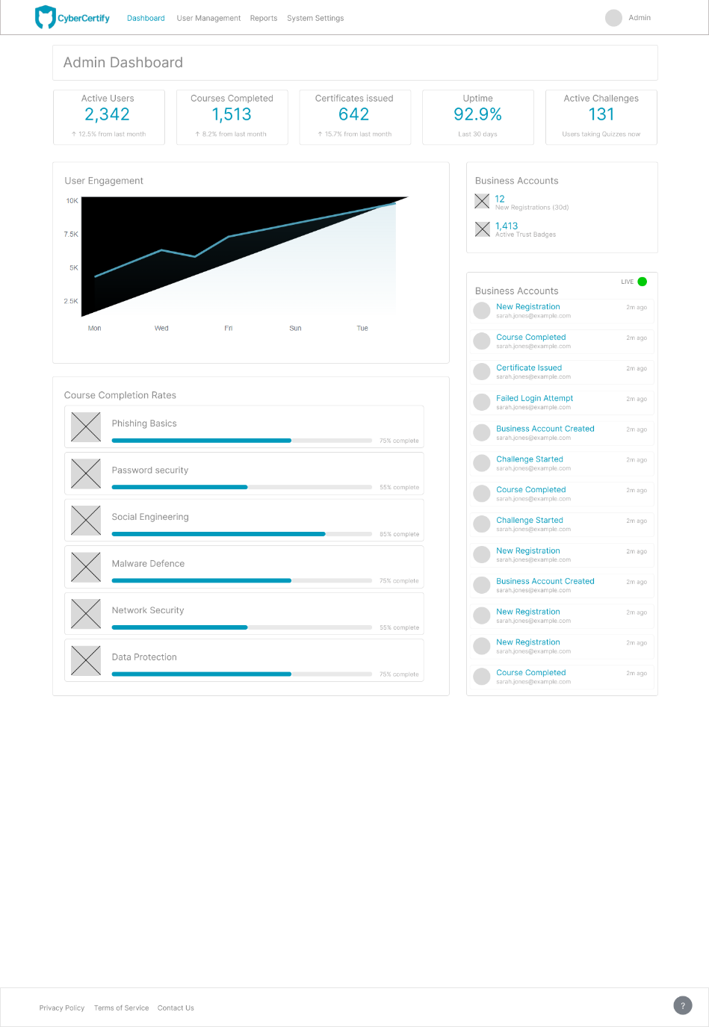
Figure 6 Admin Dashboard
Figure 6 Admin Dashboard:
Justification
The Admin Dashboard has a clear overview of key system metrics. At the top of the interface, key indicators such as active users, courses completed, certificates issued, and system uptime are displayed. This arrangement, which is in line with best practices for dashboard design where primary data is arranged hierarchically, allows for a quick understanding of system health and user engagement. Visual growth indicators, like percentage changes from the prior month, give the data important context without overpowering the user.
A real-time activity feed positioned on the right-hand side further enhances the dashboard’s utility by displaying ongoing system events such as new registrations, course completions, and failed login attempts. This feature supports situational awareness and enables quick response. The design maintains a clean, professional aesthetic using white space, and a consistent blue colour palette that reinforces the brand’s association with trust and cybersecurity reliability.

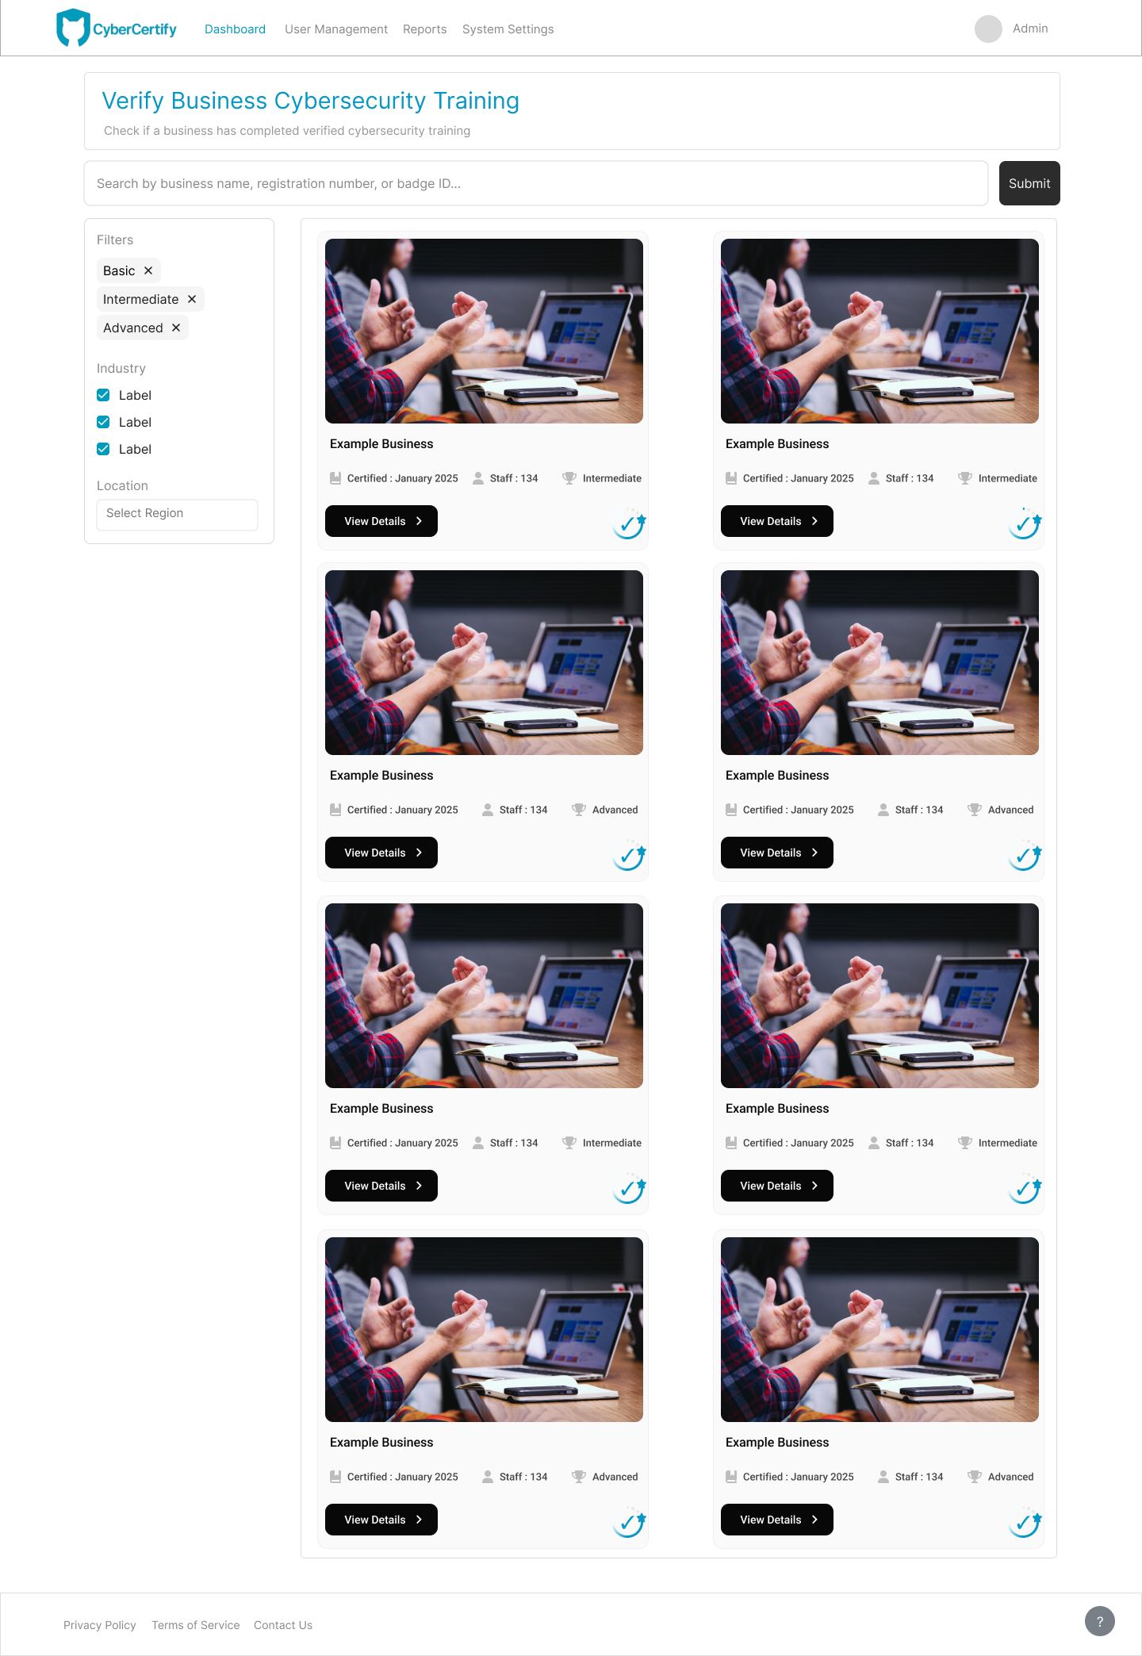
Figure 7 Business verification
Figure 7 Business verification:
Justification
The design employs a card-based structure for displaying business profiles. Each card includes a business image, certification date, staff count, and certification level, along with a clear call-to-action button labelled “View Details.” This layout is both visually engaging and highly functional, enabling users to scan and compare organisations quickly. The use of imagery and icons introduces a human element, creating a sense of authenticity that purely textual listings lack. The inclusion of filters for certification level, industry, and location ensures the system remains scalable and user-friendly even as the dataset grows.
Compared to KnowBe4 and Cybrary, CyberCertify’s business verification page provides a capability neither competitor offers. KnowBe4’s system is focused on employee training and does not include a public verification feature. Cybrary, concentrates on individual learning achievements and lacks business-level certification transparency. CyberCertify’s approach extends beyond that by creating a public trust layer, allowing verified organisations to showcase their cybersecurity maturity in an accessible manner.

Design Differentiation Compared to Competitors
CyberCertify's design was created with consistency and user familiarity in mind. Across the whole application there is an obvious structured and modern layout system present from the moment the user signs up to when they earn their certificates. Each page follows a clear visual hierarchy with the same typography, card layout, and spacing rules, allowing users to immediately catch on and recognise patterns, which ensures they are confident during navigation.
However, many competitor platforms such as KnowBe4, Infosec, and Cybrary often use dense and text-heavy layouts. These interfaces are functional but can make the user feel overwhelemed and disconnected from the platform. CyberCertify takes the opposite approach by maintaining a cohesive design across all pages, ensuring that all elements remain familiar through the whole platform. This approach improves user experience greatly and ensures smooth navigation for learners.
From a user-experience perspective, CyberCertify focuses on engagement, clarity and overall accessibility. The use of cool colours, open spacing and structured card-based layouts improves readability greatly, in addition to subtle interactive feedback and progress visuals which make the platform more engaging. Competitors like Coursera and SANS use more technical layouts that prioritise content delivery but can be overwhelming, especially for newer users. CyberCertify bridges that gap by combining a professional structure with a learner-friendly interface.
Overall, the design stands out for its consistent structure, familiar yet efficient navigation patterns and its visually cohesive layout system. Instead of relying on multiple and overwhelming design styles, which most ex isting cybersecurity training platforms rely on, CyberCertify carries out a unified platform and experience that feels clear, efficient and reliable for all users.

Comparison Summary
Competitor | Design Style | CyberCertify Difference
KnowBe4 | Uses standard corporate look with simple dashboards | Keeps familiar layout but adds a modern, consistent style across all pages
Infosec IQ | Functional design with dense layouts and lots of data | Uses more spacing and clear structure to make content easier to absorb
Cybrary | Text-heavy course lists. | Adds clear sections, feedback visuals and better navigation.
Coursera | Academic layout focused on text and videos. | Uses interactive and gamified visuals whilst keeping a professional look.
SANS Institute | Very technical and potentially overwhelming. | Creates a friendlier, more accessible interface for everyday learners and individuals.

Figure 8 Certificate generation & verification
In the Certificate generation & verification section, the user is shown which certificates have been passed or which certificates are available to them. In this design, I aimed for a simple yet up-to-date experience, dividing it into only two sections: completed certificates and certificates available for completion.

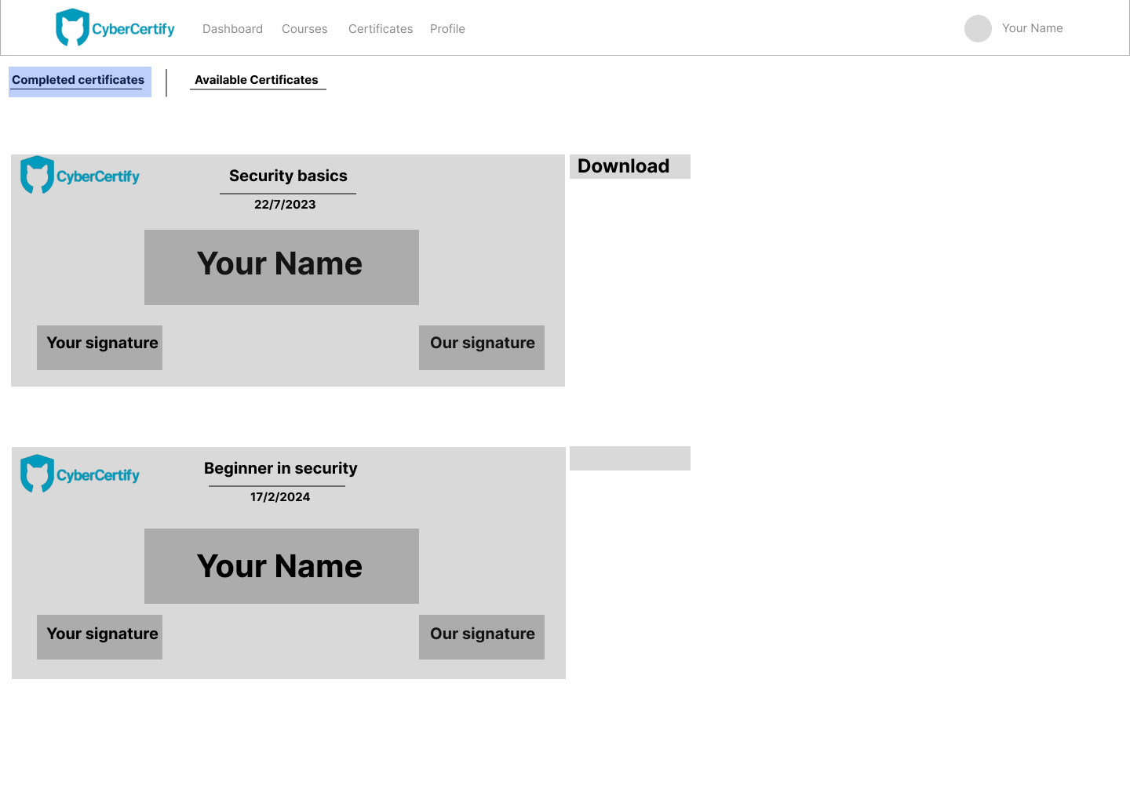
Completed certificates:
This section allows you to view only completed certificates, with a simple design that shows the completion date and course name, and of course, provides a clear button for quickly downloading the certificate.

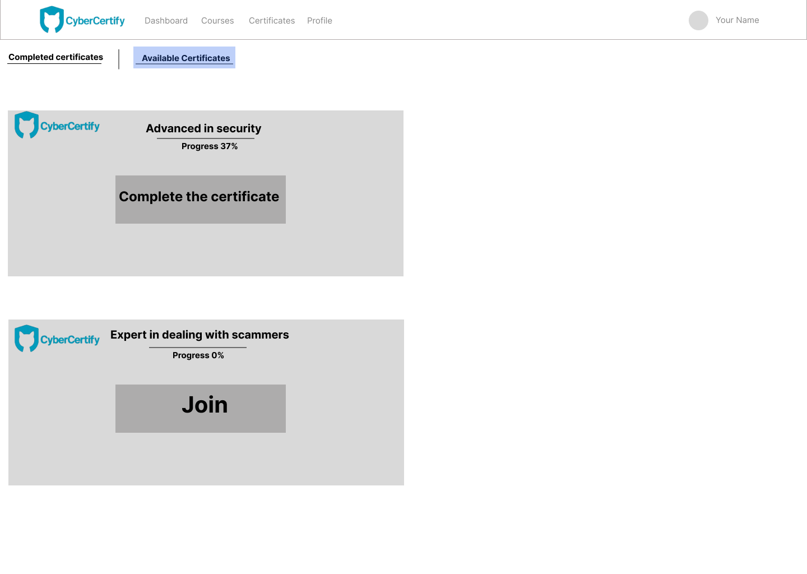
Available certificates:
This section displays the certificates available to the user, as well as those they haven't yet fully completed. It shows the certificate name and completion status; if a certificate isn't fully completed, the user can see their progress and whether they are nearing completion. If they haven't registered for a particular certificate, the option to join will simply appear on the certificate.

Comparison Summary
Competitor | Design Style | CyberCertify Difference
Coursera | Many elements, small download buttons. | Simplicity in design, organization, and clear placement of download buttons.
Udemy | There is no distinction between completed and incomplete certificates. | Completed and incomplete certificates have been separated by placing them in two separate locations, making it easier for the user to access what they need.

Briefly, this section focuses on sorting certificates for the user and making them easily accessible and organized, whether they want to download their own certificates or access other certificates.

Figure 9 Business dashboard
This section contains most of what we need to get an overview of what's happening. It includes requirements for reviewing results separately, an overview for a general view of everything, and a settings section.

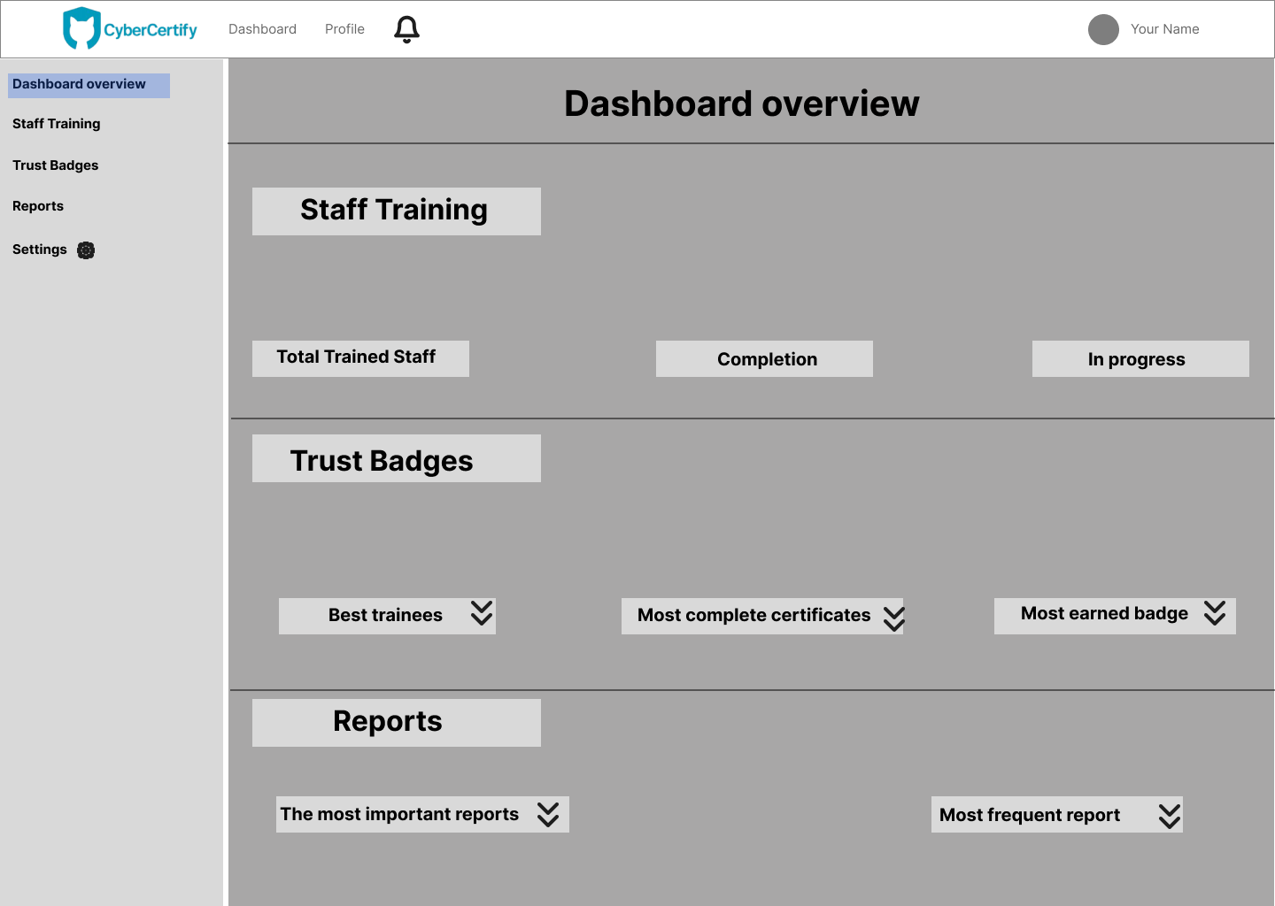
Dashboard Overview
This section provides a summary of all the other listed sections, making it easy to get a general overview of the data and access all the information if you want a quick look at what's happening.

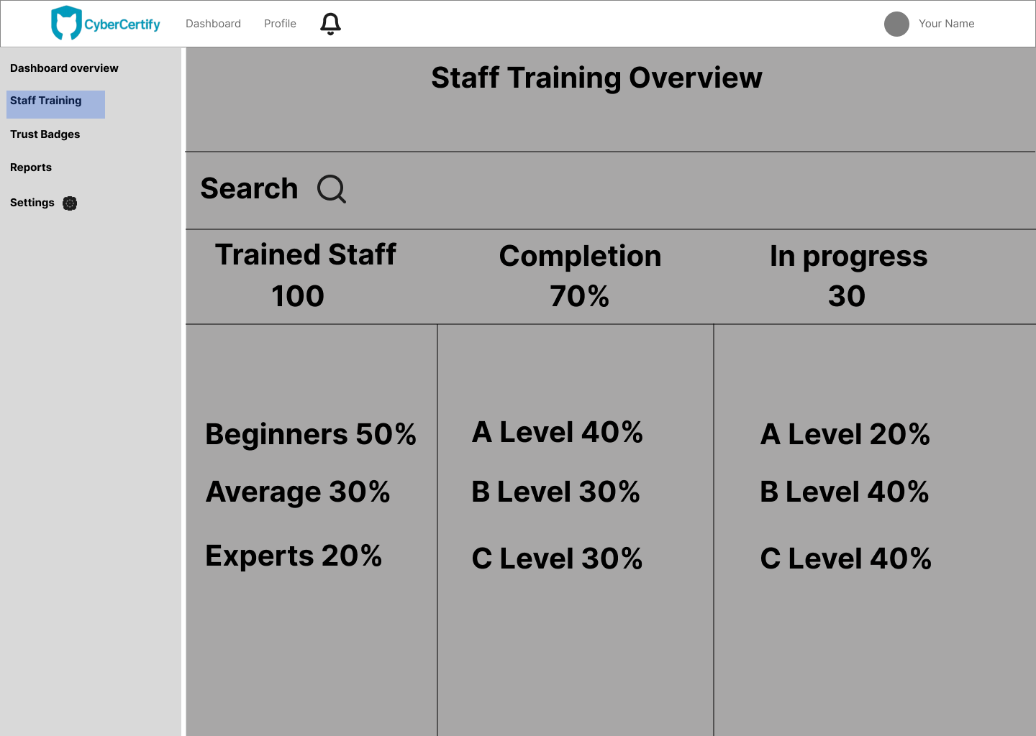
Staff training overview
This section is dedicated to staff training, where you can see the number of trainees, the percentage of completed or pending certifications, and the types of certifications. This section allows you to identify the most popular certifications and those that trainees haven't been able to complete, enabling you to make adjustments that benefit both you and your trainees.

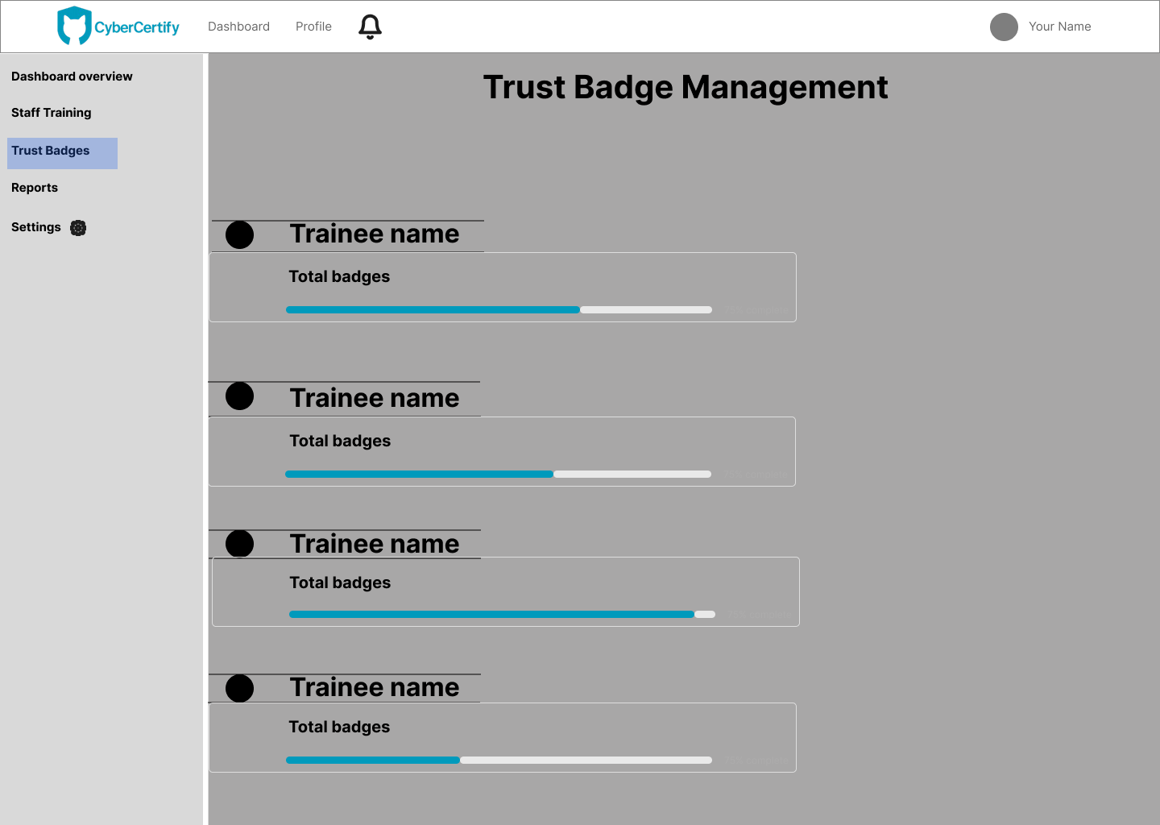
Trust badge
This section displays badges, allowing you to see the names of the trainees with the most badges and understand their training focus. This section facilitates the development of a future plan for trainees based on their interests.

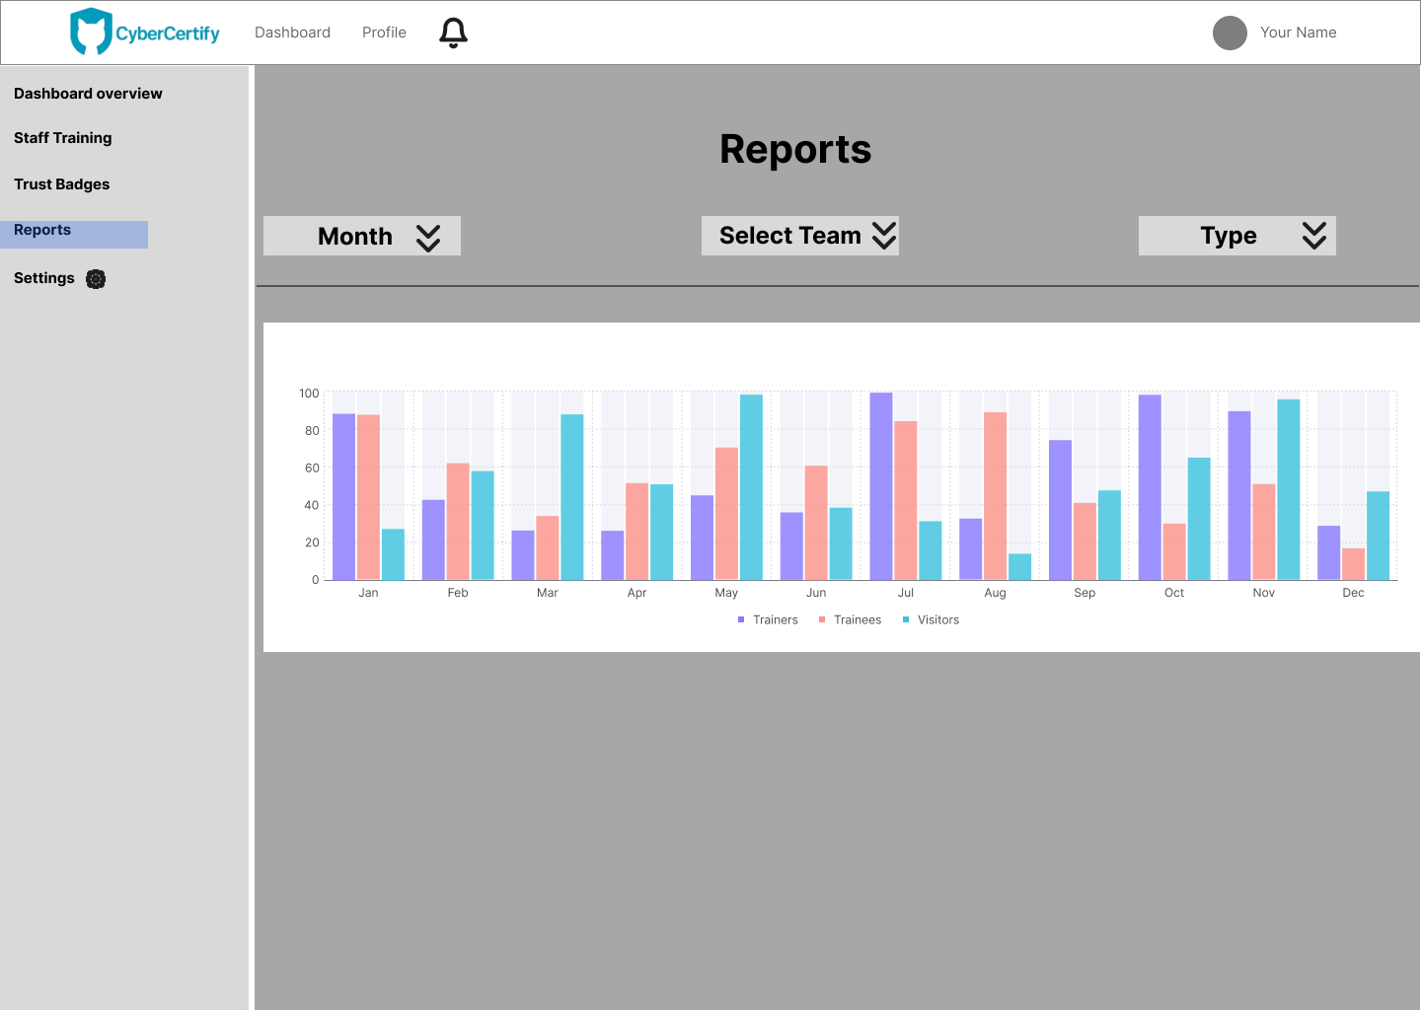
Reports
This section, responsible for displaying site-specific reports, includes a simplified graph showing the number of trainees, trainers, and even site visitors. You can also specify the type of reports you want, the section you want, and the time period. For example, you can see which month had the highest number of trainees or visitors.
However, through this simple process you can, for instance, place offers or discounts at this time to try to attract the largest number of users.

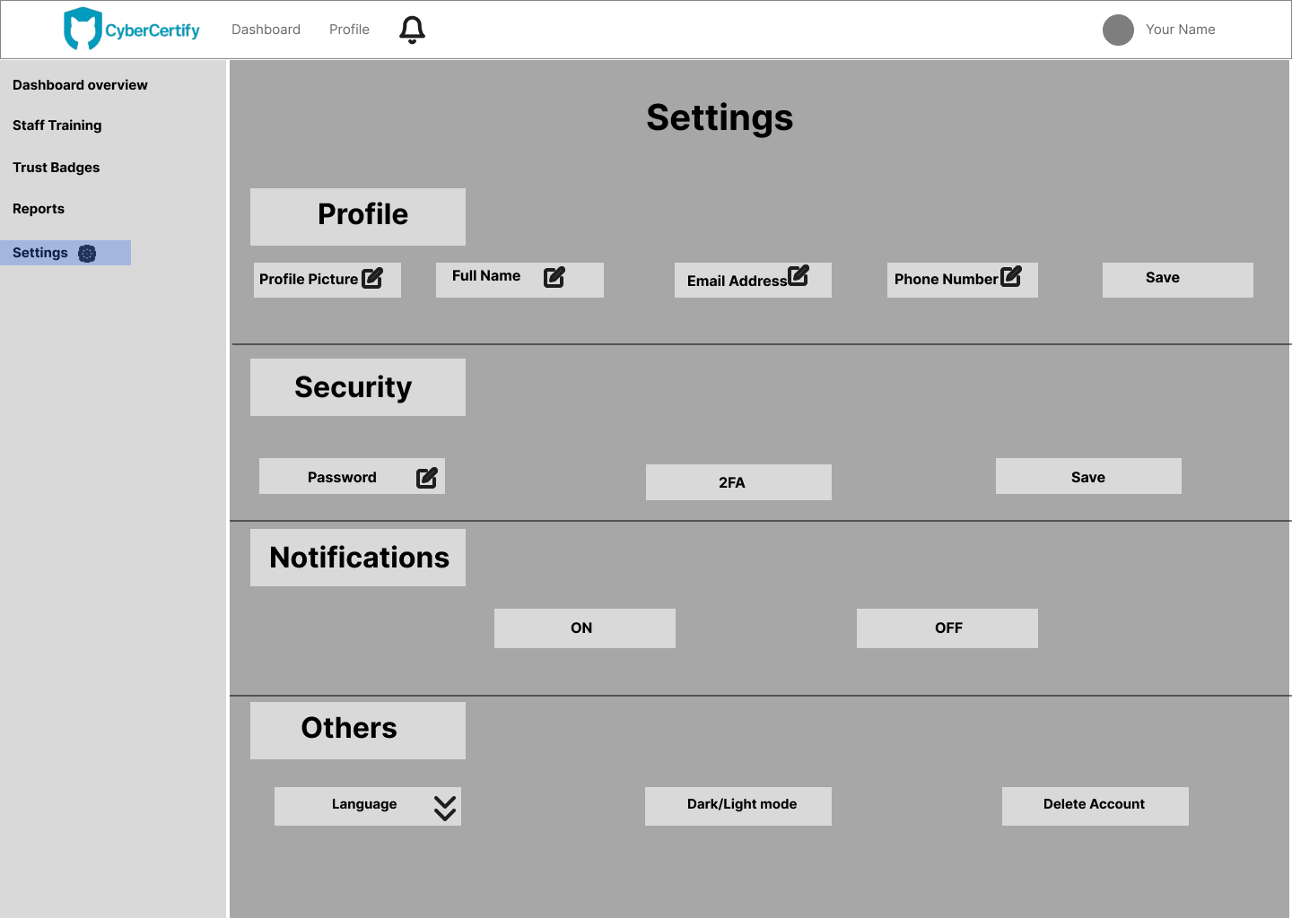
Settings
The settings section doesn't require much explanation; it's for editing your account and profile, changing your password, choosing your preferred language or theme, and enabling or disabling notifications. However, we've included two-factor authentication (2FA) for added security alongside your password. This feature makes impersonation and hacking much more difficult.

Comparison Summary
Competitor | Design Style | CyberCertify Difference
Power BI | Much of the data is unstructured. | Presenting data clearly and simply, without any complexity.
HubSpot | The numerous icons and colors may cause distraction. | There aren't many colors, the colors used are muted and don't cause distraction, focusing on the essential data, which makes it easier for you to use.

In summary, the Business dashboard focuses on displaying important data and information, while maintaining simplicity to ensure ease of use, separating sections to provide a detailed view of each section, and providing an overview for a comprehensive perspective.

Conclusion
This design specification outlines the visual and structural foundation of CyberCertify. The design focuses on creating a platform that iseasy to use, visually consistent and motivating for all learners/users. Each layout has been developed with accessibility and usability in mind, ensuring that users can navigate through the system smoothly and stay engaged with their learning progress.

